BLACK ABOLITIONISTS: TUBMAN, DOUGLASS, TRUTH

Dublin Core

Title
Black Abolitionists: Tubman, Douglass, Truth

Description
The monuments and memorials in this collection commemorate the extraordinary achievements of three Black abolitionist and freedom seekers: Harriet Tubman, née Araminta Ross, (c. 1822-1913); Frederick Douglass (c. 1818-1895); and Sojourner Truth (1797-1883).
Born into slavery on Maryland’s Eastern Shore, Harriet Tubman escaped to freedom in 1849. During the next ten years, she made approximately thirteen trips into Maryland to rescue other enslaved family members and friends. She provided instructions for escape to about 70 more enslaved people who were able to self-emancipate. During the Civil War, she served the United States Army as a spy, scout, nurse and cook. As one of the most famous conductors of the Underground Railroad, the monuments in this section often depict Tubman leading groups of freedom seekers on their journey northwards to freedom, such as Mario Chiodo’s Unwavering Courage in the Pursuit of Freedom. In other works, such as Alison Saar’s Swing Low, Tubman is depicted alone, facing southward as she makes the perilous journey back to Maryland to free more enslaved people.
One of the most brilliant orators of his generation, Frederick Douglass worked ceaselessly for the cause of abolition. Among his many achievements, Douglass became one of the early and important critical theorists of photography, a medium invented in 1839. In a series of lectures delivered between 1861-1865, Douglass argued that photography had the power to shape people’s understandings of race and as such could be deployed to resist distorted representations of African Americans. Douglass, who was exceptionally aware of the power of his own image, sat for a number of portraits over several decades, circulating his image widely. His photographic portraits serve as the basis for a number of the works in this collection, including Ivan Schwart’s Frederick Douglass, created for the New York Historical Society.
Sojourner Truth was born into slavery in 1797 in Swartekill, New York. She emancipated herself, escaping to freedom in 1826. During her 30-year career, she became a formidable force in several 19th-century reform movements, linking the struggles for Black freedom with women’s suffrage. Truth capitalized on both the affecting power of photography and its reproducibility to support her activism. She created carte-de-visite portraits of herself, which she copyrighted, adding the caption “I Sell the Shadow to Support the Substance. Sojourner Truth.” As Darcy Grimaldo Grigsby explores in her book Enduring Truths: Sojourner’s Shadows and Substance (2015), Truth “made her photographic portrait worth money in order to end slavery—and also became the strategic author of her public self.” Commemorative works such as the Sojourner Truth Memorial in Florence, Massachusetts, are based on the photographic portrait that Truth so carefully created and circulated.
Updated January 26, 2026.

Creator
Written by Grace Yasumura

Contributor
Renée Ater

Collection Items

Unwavering Courage in the Pursuit of Freedom (Wilmington, Delaware)
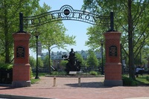
A multi-figure sculpture of Harriet Tubman and Thomas Garrett leads two fugitive enslaved persons, a semi-nude man and a fully clothed woman, along the Underground Railroad in Wilmington, Delaware. Tubman carries a baby in her arms and wears a head wrap, shawl, haversack, and carries a pistol at her waist. Garrett wears a suit, cape and top hat, and holds a lantern. The sculpture includes three pairs of boots, a crate, and a barrel. Signed by the artist: M. Chiodo, 2012.

Step on Board (Boston, Massachusetts)
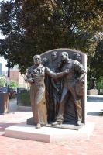
A high relief sculpture with Harriet Tubman and six figures: three women, two men, and a baby. All figures are clothed in nineteenth-century dress. Wearing a dress, shawl, and head wrap, Tubman strides forward, gesturing with her left hand and holding a bible under her right arm. The figures are backed by a vertical slab of pink granite. On the reverse of statue is a diagram of the route Tubman took when accompanying passengers on the Underground Railroad (Maryland, Delaware, Philadelphia, New York City, Albany, Syracuse, Rochester, Canada). Includes quotations from Harriet Tubman, Frederick Douglass, and Sarah Bradford.

Harriet Tubman (first cast) (Mesa, Arizona)
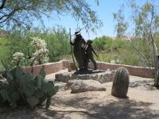
The monument depicts Harriet Tubman leading a young African American boy by her left hand and holding a long walking stick in her right. She wears a brimmed hat, a long-sleeve shirt with a shawl wrapped around her neck, and a flowing skirt. As they walk, Tubman peers kindly at the boy, who gazes back at her. The boy wears a vest, long-sleeved shirt, trousers, and laced shoes. Both figures are shown in mid-stride.
Harriet Tubman (second cast) (Brenau University, Gainesville, Georgia)
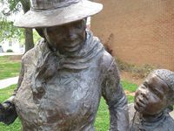

The monument depicts Harriet Tubman leading a young African American boy by her left hand and holding a long walking stick in her right. She wears a brimmed hat, a long-sleeve shirt with a shawl wrapped around her neck, and a flowing skirt. As they walk, Tubman peers kindly at the boy, who gazes back at her. The boy wears a vest, long-sleeved shirt, trousers, and laced shoes. Both figures are shown in mid-stride.

Harriet Tubman (third cast) (Little Rock, Arkansas)
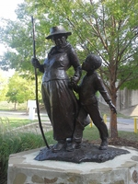
The monument depicts Harriet Tubman leading a young African American boy by her left hand and holding a long walking stick in her right. She wears a brimmed hat, a long-sleeve shirt with a shawl wrapped around her neck, and a flowing skirt. As they walk, Tubman peers kindly at the boy, who gazes back at her. The boy wears a vest, long-sleeved shirt, trousers, and laced shoes. Both figures are shown in mid-stride.
Harriet Tubman (fourth cast) (Ypsilanti, Michigan)
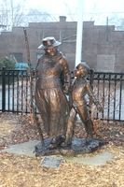

The monument depicts Harriet Tubman leading a young African American boy by her left hand and holding a long walking stick in her right. She wears a brimmed hat, a long-sleeve shirt with a shawl wrapped around her neck, and a flowing skirt. As they walk, Tubman peers kindly at the boy, who gazes back at her. The boy wears a vest, long-sleeved shirt, trousers, and laced shoes. Both figures are shown in mid-stride.

Harriet Ross Tubman Memorial (Bristol, Pennsylvania)
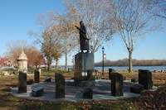
Single figure of Harriet Tubman, wearing a coat, haversack slung over her right shoulder, and a pistol at her waist. Tubman points her right hand toward the sky, symbolic of the “North Star.” Signed by the artist: James L. Gafgen, 2005. Foundry stamp: Art Research Enterprises: The Art Foundry.
Harriet Tubman (Salisbury University, Salisbury, Maryland)
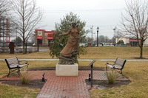

Harriet Tubman wears a nineteenth-century inspired dress. On her left shoulder sits a saw-whet owl, at her right foot rests a rabbit. She extends her right arm into the air, perpendicular to her body. Ten seashells are sculpted into the base of the monument.

Swing Low: Harriet Tubman Memorial (New York, New York)
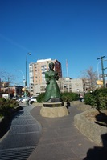
The large-than-life bronze sculpture of Harriet Tubman stands on a rough-cut granite base. Bronze tiles depicting events from Tubman’s life, along with traditional quilting patterns, adorn the upper section of the base. Tubman is shown in motion, striding forward with one hand clasping the strap of her shoulder bag. From the side, she is shown pulling away from the gnarled, root-like branches that appear to symbolize her breaking free from bondage. Her facial expression is calm and resolute. She wears a buttoned, long-sleeved shirt and a long skirt, the surface of which is adorned with small, raised faces, shackles, and other symbolic elements.

Swing Low: Harriet Tubman Memorial (reduced version) (Scripps College, Claremont, California)
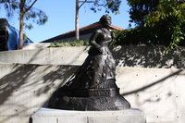
The sculptor Alison Saar created this smaller version of Harriet Tubman based on the full-scale Swing Low: Harriet Tubman Memorial in New York City. Tubman is shown in motion, striding forward with one hand clasping the strap of her shoulder bag. From the side, she is shown pulling away from the gnarled, root-like branches that appear to symbolize her breaking free from bondage. Her facial expression is calm and resolute. She wears a buttoned, long-sleeved shirt and a long skirt, the surface of which is adorned with small raised faces, shackles, and other symbolic elements.

Araminta With Rifle and Veve (ephemeral)

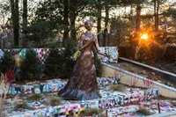
A monumental outdoor figure of Harriet Tubman depicts her wearing a collared, long dress, holding a richly decorated rifle in her right hand—with its butt adored with flowers—and a colorfully beaded ceremonial staff called veve in her left. The statue is made of milled foam and coated with a bronze-colored patina. Tubman stands on a series of steps draped with numerous colorful quilts.

Graffiti Harriet (ephemeral)

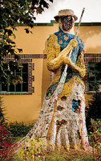
A monumental sculpture of Harriet Tubman made of soil, clay, and straw, is scrawled with the words from Frederick Douglass. The sculpture is made from perishable materials, meant to dissolve over the winter. Scott designed the sculpture so that remains will include the beaded patchwork and gun. The sculpture was installed at the Grounds for Sculpture from October 20, 2017-April 1, 2018.

Harriet Tubman (Salem Chapel, St. Catharines, Ontario, Canada)

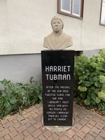
The half-bust portrait of Harriet Tubman, made from concrete, was sculpted by local artist Frank Rekrut. It rests on a rectangular plinth made of polished black marble bearing her name and an inscription. Tubman is depicted wearing her signature headscarf, with a wrap covering her shoulders. The portrait is situated in a meditation garden next to British Methodist Episcopal Church of Canada-Salem Chapel, St. Catharines, Ontario.

Harriet Tubman (St. Catharines, Ontario, Canada)
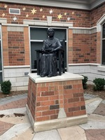
The bronze portrait sculpture of Harriet Tubman rests on a large rectangular plinth made of brick and stone. Tubman, wearing her signature headscarf, is depicted seated on a wooden chair, holding a closed book in her hands as she gazes into the distance. She wears a scarf around her neck, long-sleeved shirt button-down shirt, a shawl, and a flowing skirt.

Frederick Douglass Monument (University of Maryland, College Park, Maryland)

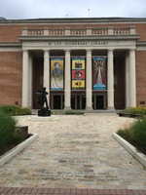
Full-size sculpture of Frederick Douglass portrays him in the middle of a speech, with one arm outstretched, and a copy of his autobiography under the other arm. His coat/cape billows out behind him in a swath of bronze.

Harriet Tubman Memorial Plaque (Auburn, New York)

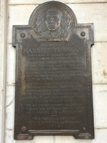
The bronze plaque honoring Harriet Tubman has a dark patina and a rectangular body topped with a rounded arch. At the top, Tubman’s portrait—based on an 1890s photograph—is rendered in raised relief and surrounded by a laurel motif. Her expression is calm and resolute. Beneath the portrait is an inscription detailing Tubman’s achievements, with floral rosettes adorning the corners of the plaque.

William Seward and Harriet Tubman Statue (Schenectady, New York)

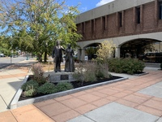
Life-size statue of William Seward and Harriet Tubman standing on Mohawk Valley ordovician dolostone inside a garden bed. Seward stands with a cane in his right hand and his left arm around the back of Tubman. He wears nineteenth-century clothing including a jacket, vest, and pants. Tubman gestures with her right hand and carries a walking stick in her left hand. She wears a bodice and skirt. Draped across her chest is a sack with the end of a revolver visible.

Frederick Douglass Memorial (Easton, Maryland)

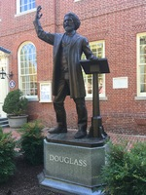
Standing to the right of a lectern, Frederick Douglass is depicted as in elder statesman, with a furrowed brow and deep lines marking his face. Captured mid-speech, Douglass raises his right hand above his head in a rhetorical gesture, while his left-hand rests atop the lectern. The life-sized bronze figure rests on a base of stone. The work is located in front of the Maryland Circuit Court Judge’s Office in Easton, Maryland. Just to the right and in the same plaza is a monument to Confederate soldiers.

Frederick Douglass Memorial (New York, New York)

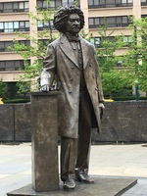
Standing to the right of a lectern, Gabriel Koren modeled Frederick Douglass is depicted as an elder statesman, with a furrowed brow and a deeply lined face. Resting his right hand atop the lectern, Douglass’ mouth is closed as he stares resolutely forward. Algernon Miller designed the granite seating and paving patterns, which are based on traditional African-American quilt motifs, as well as a bronze perimeter fence with a wagon wheel motif. Miller also created a bronze water wall that shows the Big Dipper constellation with the North Star. Quotations from Douglass embellish the site.

Frederick Douglass (West Chester University, West Chester, Pennsylvania)

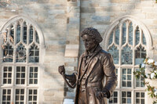
The ten-foot-tall bronze statue of a young Frederick Douglass casts his gaze forward and ever-so-slightly downward toward an imagined viewer. Standing squarely forward, Douglass' left knee is slightly raised as if he were on the verge of walking off the granite pedestal. In his right hand, Douglass holds a cane; in his left hand, he holds the end of a rope that coils around his torso and shoulders.

Let's Have Tea (Rochester, New York)

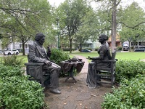
Seated in simple wooden chairs, Frederick Douglass and Susan B. Anthony engage in conversation over tea. On a table between them sits a tea pot, two teacups and saucers, and two books. Douglass leans forward, his gaze cast slightly downward, listening intently to Anthony, who sits upright in her chair.

Frederick Douglass Circle (Hempstead, New York)

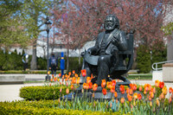
An elder Frederick Douglass is depicted seated on a scissors chair— the armrests are adorned with the faces of open-mouthed lions, while the chair’s legs have been carved in the shape of lion’s legs. In bas-relief, the chair’s back is embellished with a widely circulated 18th-century anti-slavery medallion manufactured by the English potter Josiah Wedgwood. The design, which was likely created by the sculptor Henry Webber, features an enslaved black man, kneeling and bound by chains. The text below the figure reads “Am I not a friend and a brother?” The medallion became an important emblem of the abolitionist movement in both Britain and the United States. In Douglass's right hand, he holds the text to an 1883 speech that he delivered to mark the 20th anniversary of the Emancipation Proclamation. The speech is continued on the pavement.

Frederick Douglass (Baltimore, Maryland)

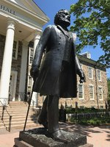
Caught mid-stride, the over life-size bronze statue of Frederick Douglass stands in front of Holmes Hall on the campus of Morgan State University, a historically Black university in Baltimore, Maryland. The bearded Douglass holds a cane in his right hand as he steps forward on his right foot.

Frederick Douglass (Hillsdale, Michigan)
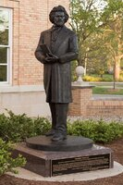
Located on Hillsdale College’s Liberty Walk, the bronze statue of Frederick Douglass is the first African American figure to be included on the Liberty Walk. The bearded Douglass clasps his hands around a book, his torso turning gently leftward as he shifts his weight to his left leg.

Frederick Douglass (New York, New York)

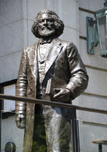
A life-size sculpture of the abolitionist Frederick Douglass stands atop the staircase at the West 77th Street entrance to the New-York Historical Society. Douglass gazes forward, holding a pair of books in his left hand, while his right arm rests downward. Fully bearded, Douglass stares off into the distance.

Frederick Douglass (Baltimore, Maryland)
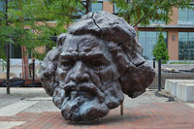
The six-foot-tall bronze head of an elder Frederick Douglass is located in the Frederick Douglass-Isaac Myers Maritime Park in Baltimore’s southeastern waterfront. The textured and rough surface of Robinson’s work creates a sense of movement as light reflects off the uneven surface, highlighting the work’s divots and crests.

Frederick Douglass Monument (Rochester, New York)

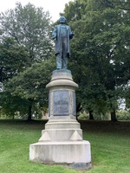
Sculptor Stanley W. Edwards modeled Douglass with his shoulders back, feet planted squarely forward, and his arms outstretched with his palms open as if he were addressing an audience. Mounted on the statue's pedestal are four bronze plaques, three of which are inscribed with quotes from Frederick Douglass. This monument was originally located in front of the old New York Central Train Station (St. Paul Street and Central Avenue) in Rochester, New York. In 1941, the work was moved to Highland Bowl, a part of Highland Park, close to the location of Douglass' farm (no longer extant) on South Avenue. Photos of the monument were taken in Highland Bowl, Highland Park, Rochester, New York in 2018. In October 2019, the City of Rochester moved the monument to a newly designated Frederick Douglass Memorial Plaza at South Avenue and Robinson Drive.

Frederick Douglass (Rochester, New York)
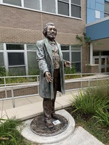

To mark the bicentennial of Frederick Douglass’ birth, the City of Rochester, NY, commissioned Olivia Kim to create thirteen live-size portraits of Douglass in 2018, placing them throughout the city at sites significant to Douglass’s life and work. Kim took inspiration from Stanley W. Edwards’ nineteenth-century statue of Douglass, originally erected in front of the old New York Central Train Station in Rochester, New York. Although the works are fiberglass, Kim recreated the patinated bronze of Edward’s original work. Like Edward's original work, Douglass’ arms are slightly outstretched, his palms open upward. Kim used the hands of Kenneth B. Morris Jr., the great-great-great-grandson of Douglass, to create the hands of Douglass in her own work.
In 2023, the City of Rochester acquired ten of the statues, which are undergoing repair and restoration. They will be placed in ten new indoor locations. The remaining three statues are in the care of RCTV, Rochester Educational Opportunity Center, and the University of Rochester.

Sojourner Truth Monument (Battle Creek, Michigan)

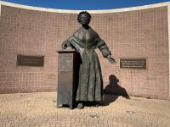
The monumental bronze figure of Sojourner Truth stands behind a concave wall, on an elevated semi-circular stage. She stands to the left of a lectern, her left arm outstretched at her side as she looks out at an imagined audience. She places her right hand on the book that rests atop the lectern. Truth is shown bespectacled, wearing a scalloped-edge bonnet, fringed shawl, and floor-length dress. A bronze plaque describing Truth’s life and accomplishments is affixed to the front of the lectern. The concave wall behind Truth is embellished with bronze plaques bearing quotes from Truth.

Sojourner Truth Memorial Statue (Florence, Massachusetts)

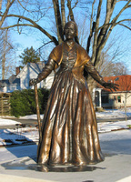
The life-size bronze figure of Sojourner Truth stands at the center of a square granite base. Truth is shown bespectacled, wearing a period-appropriate head covering, long scarf, and floor-length dress. Her arms are open at her side, in an inviting gesture. She holds a walking stick in her right hand.

Sojourner Truth (San Diego, California)

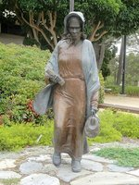
The life-size bronze figure of Sojourner Truth holds a bible in her right hand and carpetbag in her left. Clad in a simple, unstructured dress, bonnet, and shawl draped around her shoulders, Truth strides forward as if in motion.

Sojourner (Sacramento, California)

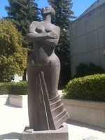
Unlike many sculptural representations of Sojourner Truth, Elizabeth Catlett’s work is geometrized and slightly abstracted. Truth is shown with her arms crossed at her chest as she tilts her head skyward, her eyes closed. The flared skirt of her form-fitting dress adds to the work's sense of upward movement. The stone is polished smooth, save for Truth’s hair, which, although abstracted, is shown uncovered in cropped curls.

Sojourner Truth (Highland, New York)

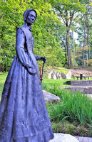
Vinnie Bagwell's seven-foot-tall bronze statue of Sojourner Truth reveals a bespectacled, a middle-aged woman who stares resolutely forward, her head turned slightly to the right. Bagwell, perhaps taking inspiration from this undated carte de visite of Truth, shows Truth with her right arm outstretched by her side and a cane in her left hand. The folds of her skirt depict moments from Truth's life including images of a young, enslaved mother comforting her child, a slavery sale sign, images of her abolitionist peers, and a poster for a Women's Suffrage March.

The Beacon of Hope: Harriet Tubman Monument (Cambridge, Maryland)

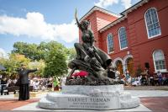
Facing true North, a bronze monument of Harriet Tubman and her younger self, Araminta Ross, stands atop a granite base. With her right foot planted firmly on an oxen yoke, Tubman uses her left foot to propel herself upward. She gazes into the eyes of Araminta Ross, handing her a golden key. Tubman's right hand is raised, encircled by a rose compass—both adorned in gold leaf. Araminta Ross’ hand hovers over the key as she looks up at Harriet Tubman. She is seated atop countless chains and shackles, some open and others closed. The base features rugged steps on either side of the figures, with inscriptions on both the front and back. Parallel to the monument, an open-faced book atop a podium presents an overview of Tubman's life. The back of the podium features the sculptor Wesley Wofford's description of the monument in his own words.

The Traveling Exhibition: Harriet Tubman - The Journey to Freedom (Montgomery, Alabama)

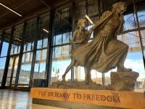
The sculpture depicts Harriet Tubman and a young girl caught in brisk motion against the wind, navigating treacherous terrain. Tubman’s left foot rests on an elevated platform, propelling them forward while her right foot pushes upward toward the incline. She grips the collar of her jacket with her left hand, as her right arm twists back to support the girl following behind her. The girl holds Tubman’s right arm with her left hand and grasps Tubman's right index finger between her thumb and forefinger. Tubman’s skirt partially covers the girl’s lower half. Near the girl’s bare feet lie a set of broken manacles.
This monument was created in 2020 with the intention of traveling across the United States. Since then, the monument has traveled to the following locations: The Equal Justice Initiative Legacy Pavilion in Montgomery, Alabama (2020); Harriet Tubman Museum in Cape May, New Jersey (2020 and 2021); Dorchester County Courthouse in Cambridge, Maryland (2020); Newburgh Free Library in Newburgh, New York (2020); Jan Peek Square in Peekskill, New York (2020); Halifax State Historic Site in Halifax, North Carolina (2021); Haverstraw African American Memorial Park in Haverstraw, New York (2021); Bridge Park in Sylva, North Carolina (2021); Philadelphia City Hall in Philadelphia, Pennsylvania (2022); Renaissance Plaza in White Plains, New York (2022); The Harriet Tubman Home in Auburn, New York (2022); Washington Square Park in Rochester, New York (2022); Ulster County Office Building in Kingston, New York (2022-2023); Dr. Martin Luther King, Jr. Elementary School in Lancaster, Pennsylvania (2023); Button Farm Living History Center in Germantown, Maryland (2023); The Frampton Plantation House in Yemassee, South Carolina (2023); Joseph Rainey Park in Georgetown, South Carolina (2023); Brookgreen Gardens in Murrells Inlet, South Carolina (2023-2024); Legacy Plaza in Montgomery, Alabama (2024); The Kerr Community Center in Bastrop, Texas (2024); and the International African American Museum in Charlestown, South Carolina (2024). Additional locations are scheduled for 2025 and beyond. For the sake of clarity, CMSP has decided to document this monument only once, based on the details from its initial unveiling.

The Traveling Exhibition: Harriet Tubman - The Beacon of Hope (Cape May, New Jersey)

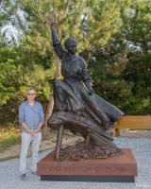
A bronze sculpture of Harriet Tubman stands firmly atop an oxen yoke. She stares into the eyes of the viewer, offering a golden key. Her right hand is raised, encircled by a rose compass—both adorned in gold leaf. Underneath the yoke lie countless chains and shackles, some open, others closed. The base features inscriptions on the front and back, bearing her name and the title of the work. In many of the cities, the monument is accompanied by a plaque featuring a quote by Harriet Tubman and Wesley Wofford’s artist statement.
Created in 2023, the monument was designed to travel across the United States. Since then, it has been displayed at the Cape May Point Arts and Science Center in Cape May, New Jersey (2023); the Government Office Building in Salisbury, Maryland (2023-2024); City Hall Plaza in Rahway, New Jersey (2024); the National Underground Railroad Freedom Center in Cincinnati, Ohio (2024); the corner of Central Avenue and North Division Street in Peekskill, New York (2024); and the John Brown Farm State Historic Site in Lake Placid, New York (2024), with more locations planned in 2024 and beyond.
For the sake of clarity, CMSP has decided to document this monument only once, based on the information from its initial showing.

Shadow of a Face: Harriet Tubman Monument (Newark, New Jersey)

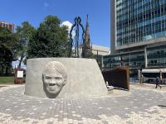
A larger-than-life metal structure outlining a figure of Harriet Tubman stands at the site where a statue of Christopher Columbus once stood. Two sloped and offset semi-circular walls surround the metal structure. One of the walls is made of unfinished concrete; on its outer perimeter is a striking relief of Harriet Tubman’s face, assembled like a puzzle. On the inner perimeter are a series of blue tiles featuring varied designs. The other semi-circular wall, known as the Learning Wall, is composed of metal and wood planks. Its outer perimeter features a timeline of Harriet Tubman’s life, while the inner perimeter presents paragraphs of text under the heading Newark’s Black Liberation Heritage.
The central metal structure in anchored to the ground with six vertical metal beams, along with six horizontal beams that extend over the Learning Wall, forming a trellis-like structure representing Tubman’s cloak. At night, a series of ground lights encircle the monument, illuminating the metal structure and trellis, backlighting the Newark’s Black Liberation Heritage text, and highlighting the bench beside the concrete wall.
On-site, the viewer can hear oral histories from members of the Newark community responding to the question, “What is your story of liberation?” as well as Queen Latifah’s narration of Tubman’s stories and Newark’s history. Community members were also invited to carve abstract representations of their narratives into the blue tiles, which appear on the concrete wall alongside their recorded stories.

Harriet Tubman Statue (Pomona, California)

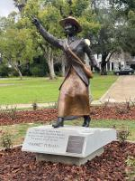
A bronze sculpture of Harriet Tubman stands atop a rugged granite base. With her right foot stepping forward, Tubman strides confidently, her right hand pointing toward the sky. She wears a copper-toned hat, a satchel, and pleated skirt, a double-breasted jacket, and laced boots. There is an inscription on the front of the monument’s base.

The Harriet Tubman Monument (Beaufort, South Carolina)

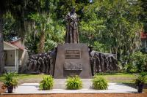
The monument depicts Harriet Tubman, co-leader of the military operation now known as the Combahee River Raid (also called the Combahee Ferry Raid), which took place in South Carolina on June 1, 1863. During the raid, more than 700 enslaved people liberated themselves using riverboats under Tubman’s command. Harriet Tubman stands as a central figure atop a large pedestal, her right hand grasping a walking stick and her left hand extended backward toward the people. She wears a head wrap, a shawl tied at the waist, and a long, pleated skirt. Tubman is flanked by relief wings that depict two Union soldiers and fifteen people seeking freedom. The Union soldiers, positioned on either side, stand in uniform with rifles held upright, their butts resting on the ground. The people seeking freedom—eight on one side and seven on the other—emerge from the textured bronze, shown walking. Some carry bundles of belongings at their sides or on their heads; others hold the hands of children. A relief of a nineteenth-century steamboat and plaques with inscriptions are located on the front of the monument.

