Steps to clean the staffing hours per resident day variables in the Biennial Survey of Long-Term Care Facilities Years 2007-2015

- Clean resident census data: Resident census data are derived from the following portion of the Biennial Survey of Long-Term Care Facilities. The screenshot is taken from the year 2015 of the survey. Administrators are requested to fill the average monthly number of residents in the residential care facility (Ohio’s term for assisted living communities). To create the denominator for measure of the number of staff per resident day, average number of residents in all of the months where there is no missing data.
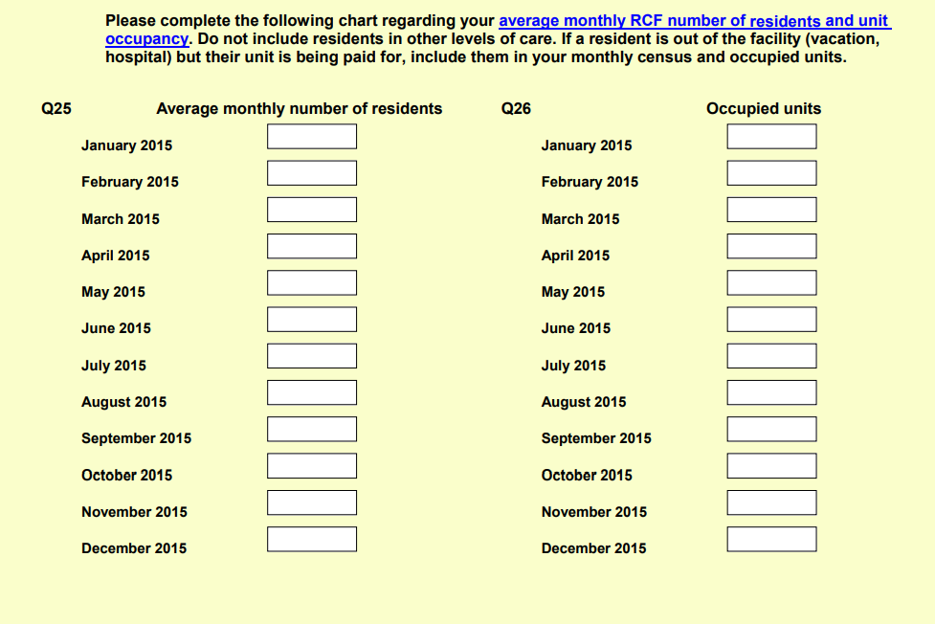

Check for implausible values by following the steps below.
  - If the number of residents is missing or 0, check to see if we have data provided by Vital Research. Vital Research is a consulting company that Ohio contracts with to collect data. On one day, during the same year the Biennial Survey of Long-term Care Facilities is administered, a researcher from the consulting company counts the number of residents in the building of each assisted living community.
  - If we have Vital Statistics data but not data from the Biennial Survey of Long Term Care Facilities, fill in the missing residents with data from Vital Research.
  - Check to see If the number of residents is greater than the number of beds.The number of residents should not exceed the number of beds in an AL community.
The number of beds is requested by the following question of the survey:
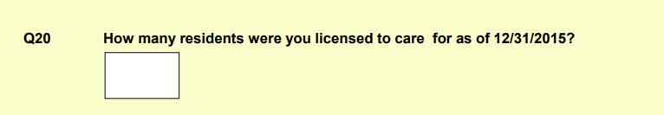

  - If the number of residents is greater than the number of beds, check whether the administrator added up the average daily census over the days of the month
    - If the number of residents is greater than the number of beds by a factor of more than 15, then we assume that the administrator summed the average daily census over the days of the month. We chose the number 15 because it assumes approximately a 50% occupancy rate (a flag for an unusually low occupancy rate) in the month. If the administrator summed the average daily census over the days of the month, divide the number of residents by 30.5.
Examples of values imputed are below:

Administrator reported resident census | Administrator reported licensed beds | Corrected resident census
408.75 | 22 | 13
452.08 | 20 | 15
2235.17 | 95 | 73
1001.67 | 42 | 33
829.58 | 37 | 27

e) Examine if there are facilities with a greater number of residents than beds.
i) If the number of residents is more than twice the number of beds, exclude the
facility. This represents an implausible value. The administrator likely reported for other units in their facility (e.g., nursing home beds). They likely also included nurses from their nursing homes in their staffing data.
ii) If the number of residents is less than twice the number of beds, keep the administrator's reported census on the assumption that some beds may be double occupancy units. Examples of ei. and eii. are below.

Administrator reported resident census averaged over 12 months | Administrator reported licensed beds | Included or excluded
92.25 | 34 | Excluded
72.5000 | 72 | Included
59.2500 | 58 | Included
95.1667 | 83 | Included

f) Check if the occupancy rate may be too low to be plausible. Calculate the occupancy rate and examine whether it is lower than 50%.
i) If the occupancy rate is 50% or lower, flag the value to compare to the Vital Research data.
g) The Vital Research measure is a measure of the resident census at only one point in time. Therefore, if the average number of monthly residents reported in the Biennial survey is only slightly lower or slightly higher than the Vital Research data’s reported value, it may still be plausible.
i) Check to see if the Vital Research resident census measure falls within the range of values the administrator reported for each month in the Biennial Survey of Long-Term Care Facilities.
ii) If the Vital Research census measure falls within the range of the administrator reported census, keep the measure.
iii) If the Vital Research measure is greater than the maximum number of residents in each month reported by the administrator or lower than the minimum number, change the resident census measure to what is reported from Vital Research. Examples are below.

Administrator reported minimum census | Administrator reported maximum census | Administrator reported census averaged over 12 months | Vital Research census | Corrected value
29 | 37 | 33.9 | 24 | 24
95 | 103 | 98.4 | 68 | 68
69 | 74 | 71 | 78 | 78
53 | 66 | 60.5 | 119 | 119
46 | 52 | 49.6 | 58 | 58
0 | 21 | 7.0 | 49 | 49

- Clean direct care staff (Aide, LPN, and RN) worker data. Direct care staffing values are taken from the staffing module portion of the survey in 2015. First, administrators are asked what payroll period is used for the majority of their employees.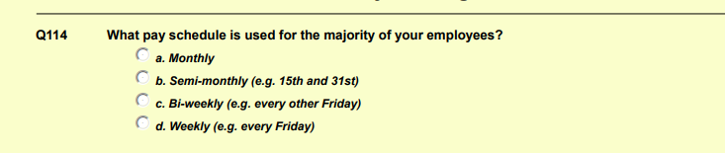
Then, administrators are asked about the number of hours the staff work in the first payroll period in 2015. These questions are asked regarding RNs, LPNs, and aides. An example from 2015 is shown below.

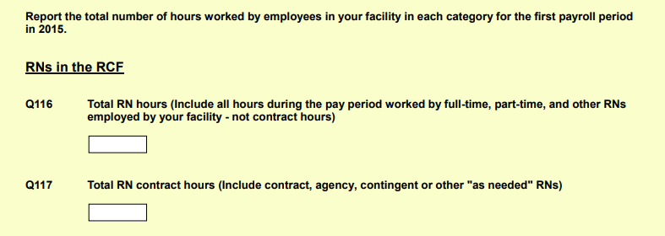
- Check for implausible values by following the steps below:
  - Add contract and non-contract hours together for each type of worker. If the number of aide hours are missing or 0 exclude the facility. We assume that an assisted living community has a non-0 number of aides because a definition of assisted living is a one that provides at least 2 meals a day, around-the-clock supervision, and help with personal care. If LPN or RN numbers are missing, exclude the facility. Not all assisted living communities have nurses, so the RN and LPN staffing number can be 0. If the payroll information is missing, exclude the facility. Document how many facilities are excluded in this step.
  - Flag any facility with aide hours per day >= 5.25 or total staff hours per resident day >= 12 as implausible, which is based on the rules CMS uses to clean staffing values for its Care Compare data.
  - If the staff numbers are implausible (>=5.25 hrs per resident day for aides or >=12 hrs per resident day for total direct care staff) check to see if we have information from the OSHA section of the survey. We can use this information to validate our numbers from the staffing module. The OSHA section asks administrators to fill in numbers that they provided on a state-mandated form of total hours worked by all employees. The question taken from the OSHA section is shown below.
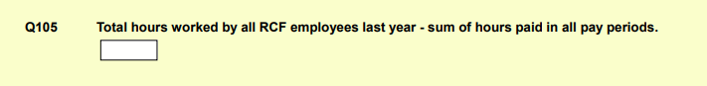
  - If we have data from the OSHA section for the facility, we can use it to check whether the administrator accidentally reported the staff hours per year rather than the hours per payroll period.
    - First, we need to convert the Biennial Long-Term Care staffing information to a yearly value (rather than a value reported for the payroll period) in order to make it comparable to the OSHA section. For all facilities, convert the total hours of staffing reported in the Biennial Survey of Long-Term care for each staff type (aide, RN, LPN) to a yearly value, using the reported payroll period to dictate the multiplier (e.g., if payroll was monthly, multiply the total staffing value by 12).
    - Add the total yearly number of Biennial Staff (aides, RNs, and LPNs).
    - For all facilities, calculate a ratio of the total yearly staffing hours reported in the staffing module to the total yearly staffing values reported in the OSHA section.
    - If the ratio of total Biennial staff hours to OSHA hours is equal to or less than 1, consider that the administrator correctly reported the staffing hours for the payroll period rather than the year. Ratios of Biennial staffing numbers to OSHA numbers <= 1 are considered to likely be reported for the payroll period because the direct care hours (aides, RNs, and LPNs) will be some fraction of the total hours reported in OSHA (OSHA includes direct care, but also other staff such as cooking and cleaning).

Table x. Examples of the staffing module to OSHA ratios
Total Biennial staff hours per year (LPN+RN+Aide) from the staffing module | Total yearly staffing reported in OSHA section (includes direct care and other staff such as activities) | Ratio of Biennial to OSHA  (<=1 plausible, >1 implausible) | Plausible or implausible
352992 | 23281 | 15.1622 | Implausible
519818 | 32435 | 16.03 | Implausible
15340962 | 58833 | 260.75 | Implausible
93808 | 187549 | 0.5 | Plausible
55848 | 78110 | 0.71 | Plausible

    - If the ratio of total Biennial staff hours to OSHA hours is over 1, consider the staffing numbers may represent yearly rates. Multiply the 1th and 99th percentile values of the ratios under 1 by a factor that corresponds to the payroll period reported in Biennial data. Doing so creates a range of ratios for each payroll period representing values that may indicate an administrator reported for the year rather than the payroll period.

Payroll period | Payroll period multiplier | 10th percentile of staffing module/OSHA ratios | 90th percentile of staffing module/OSHA ratios | Range of staffing module/OSHA ratios potentially reporting for year
Month | 12 | .03 | 1.0 | .36-12
Semi monthly | 24 | .03 | 1.0 | 7.2-24
Biweekly | 26 | .03 | 1.0 | .78-26
Weekly | 52 | .03 | 1.0 | 1.56-52
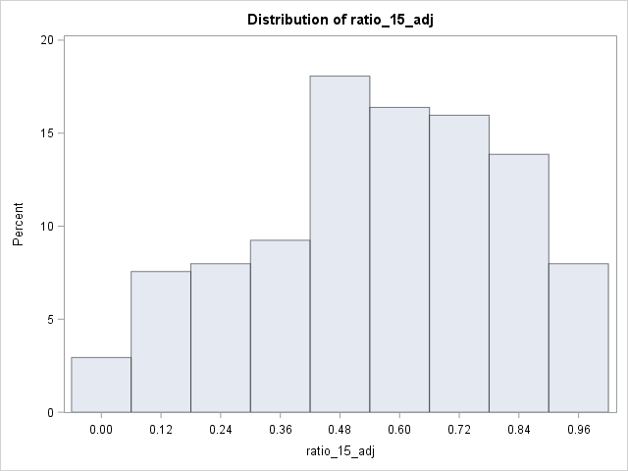
    - If the ratio of Biennial data to OSHA data (among the values over 1) does not fall in the range of ratios corresponding with its payroll period (from step 2div), exclude the facility. It likely did not report for the year, but we don’t know why its staff hours are too high.
    - For the facilities with ratios of Biennial to OSHA data >1, if the Biennial/OSHA ratio falls within the 1st-99th percentile values of the Biennial/OSHA ratios corresponding with its payroll period potentially reporting for the year (from step 2div), create a flag indicating that the AL may have reported yearly numbers.

Staffing module/OSHA ratio reported | Range of staffing module/OSHA ratios potentially reporting for year | Reported for year: yes/no
15.1622 | 2.34-24.96 | Yes
14.7985 | 2.34-24.96 | Yes
3.0000 | 2.34-24.96 | Yes
17449.71 | 2.34-24.96 | No
27.00 | 2.34-24.96 | No
0.56 | 2.34-24.96 | No

  - For facilities flagged in 2dvi as reporting for the year and are implausibly high, correct the hours per resident day value for yearly reporting by dividing the original staffing value by 365 before dividing by resident day.
    - If the aide or total staffing values per resident day are still too high after dividing the total staff number by 365 (i.e., aide hours >=5.25 hours per resident day or total staff per resident day >=12), exclude the facility. Take note of how many are excluded.
    - If the aide or total values per resident day are <5.25 and the total staff hours per resident day are <12 after dividing the original total staffing value by 365, use the corrected values in the cleaned dataset.

Original total staff hour per resident day value | Staff hour per resident day value after correcting for yearly reporting | Keep corrected value or exclude entirely from dataset
478.614 | 19.8877 | Exclude
99.583 | 3.8196 | Keep
52.147 | 2.0000 | Keep

  - If the number of direct care staff hours per resident day are >= than 5.25 or the total number of staff hours per resident day are >=12 and we do not have OSHA data for the facility, check whether the administrator accidentally reported the annual staff hours rather than the hours per payroll period. For facilities where we don’t have OSHA data, we can still use the facilities with the OSHA data to establish an empirically informed ‘plausible’ range for keeping data.
    - For all facilities, convert the total hours of staffing reported in the Biennial Survey of Long-Term care to a yearly value, using the reported payroll period to dictate the multiplier (e.g., if payroll was monthly, multiply the total staffing value by 12). Add the total number of Biennial Staff (aides, RNs, and LPNs) together.
    - Calculate the ratio of yearly staff hours in the Biennial to the total OSHA hours for all facilities where we have data available. For years where the OSHA question is not asked (2007, 2009), we will use values from 2011 (the middle year).
    - Take the 99th percentile value of total staff hours per resident day reported in the Biennial Survey for the facilities with ratios of Biennial data to OSHA data <=1 and multiply them by a factor that corresponds to the payroll period reported in the Biennial data. This step creates a maximum of total staff hours per resident day for each payroll type that may represent that an administrator reported for the entire year. We did not establish a minimum bound for this step as we did for step 3dv, as the 1st percentile value multiplied by the payroll period multiplier was typically a plausible staffing ratio(<12 staff hours per resident day)
Payroll period | Payroll period multiplier | 99h percentile of staffing hours per resident day | Staffing hours per resident day potentially reporting for the year
Month | 12 | 7.62 | 86.88
Semi monthly | 24 | 7.62 | 173.76
Biweekly | 26 | 7.62 | 188.24
Weekly | 52 | 7.62 | 376.48

    - If the total hours per resident day is above the maximum number of hours per resident day corresponding with its payroll period (from step 2fiii), exclude the facility. It likely did not report for the year, but we don’t know why its staff hours are too high.
    - If the total hours per resident day is lower than the maximum hours per resident day corresponding with its payroll period (from step 2fiii), create a flag indicating that the AL may have reported yearly numbers.

Total staff hours per resident day reported in staffing module | Maximum staffing value potentially reporting for year | Reported for year: yes/no
45.891 | 173.76 | yes
130.902 | 188.24 | yes
99.013 | 188.24 | yes

  - For facilities flagged as reporting for the year, correct the hours per resident day variables for yearly reporting by dividing the original staffing values by 365.
    - If the aide staffing values per resident day are still too high after dividing the total staff number by 365 (i.e., aide hours >=5.25 hours per resident day or total staff per resident day >=12), exclude the facility. Take note of how many are excluded.
    - If the aide values per resident day are <5.25 and the total staff hours per resident day are <12 after dividing the original total staffing value by 365, use the corrected values in the cleaned dataset.

Original total staff hour per resident day value | Staff hour per resident day value after correcting for yearly reporting | Keep corrected value or exclude entirely from dataset
45.891 | 1.90685 | Keep
40.903 | 1.56879 | Keep
99.0130 | 1.96254 | Keep
Note: In this example, there were no values that were still too high after correction

