LANGUAGE OF ENSLAVEMENT (2022)
At Contemporary Monuments to the Slave Past, we are thinking hard about the language of slavery and enslavement. The Frederick Douglass National Historic Site (NPS) offered one model for language usage. The words we use about the past profoundly shape how we understand chattel slavery and the enslaved in the present. See https://www.nps.gov/frdo/learn/education/language-of-enslavement.htm.
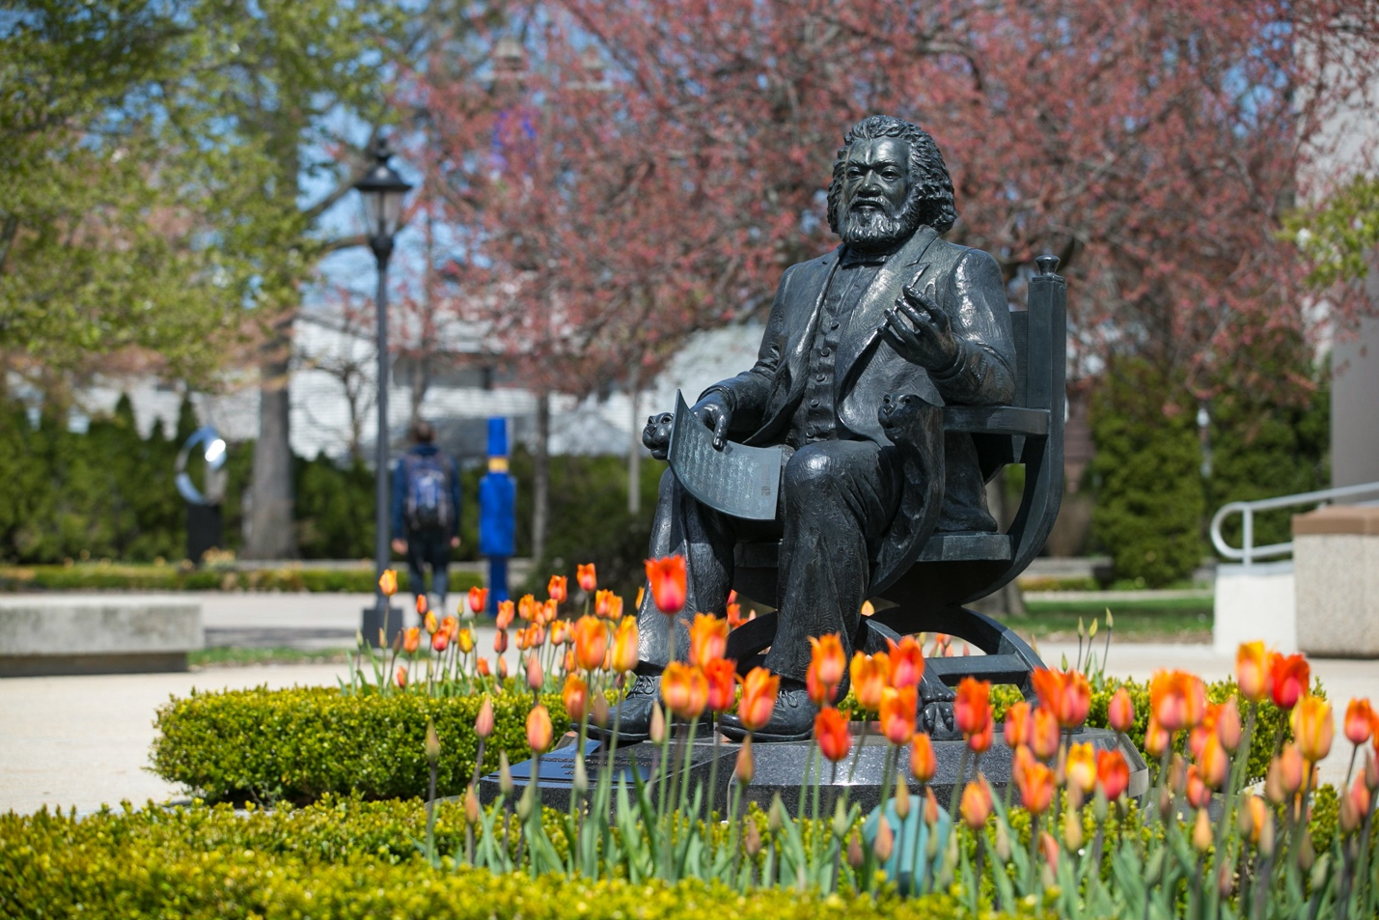
Vinnie Bagwell, Frederick Douglass, 2002, Hofstra University, Hempstead, New York. Photograph: Hofstra University.
"The impact of this language is personal. It is broadly and deeply felt. It connects to families, history, and personal experiences. It is important to accurately describe the history of enslavement in American history without perpetuating power-laden terms of a bygone era that embrace an unjust political system that abused and dehumanized millions. . . . We recognize that even intentional language choices cannot fully grasp the horrors of American enslavement. As Douglass penned describing an atrocity at which he was present, “Language has no power to convey a just sense of its dreadful criminality.” However, we – like him – must try. We do not propose the below as the final word on the subject, nor comprehensive of every possible term to consider. We welcome this continued conversation as we explore these terms so closely interconnected with the life and times of Frederick Douglass. Words matter. The language we use for enslavement matters." --National Park Service, July 2022

Terms/Language
Traditional Term | Frederick Douglass NHS Language
Slave | Enslaved
To be a slave implies that is your identity. It describes an individual on someone else’s terms. An individual must not be defined by a condition thrust upon them. It is not who they are. It lessens their humanity. Saying: “They were a slave,” carries fundamentally different meaning than saying, “They were an enslaved person.” With ENSLAVED, it first and foremost identifies the person as a human being. What has happened to this person? They have been enslaved by someone, but their primary identity is still the individual. That enslavement can also end. It is not a permanent condition. However, being a human is permanent. Systems of oppression can be instituted to enslave people, but no one is naturally a slave. Those same systems can also be dismantled. By acknowledging them as ENSLAVED persons, we embrace their individuality, value their humanity, and remember that enslavement was created by people – and can therefore be destroyed by people. There will always be resistance to oppression. The ENSLAVED INDIVIDUALS regularly resisted these systems.
“You have, dear reader, seen me humbled, degraded, broken down, enslaved, and brutalized; and you understand how it was done; now let us see the converse of all this, and how it was brought about; and this will take us through the year 1834.” – Frederick Douglass, 1845
Traditional Term | Frederick Douglass NHS Language
Master | Enslaver
Master, or Owner, places someone in charge. It gives them authority, or possession of a human life. These terms reinforce the power dynamics and show the difference between those presumed to hold the power, as contrasted against those often depicted as powerless. Master and Owner also reinforces the idea that these people are property and therefore less than – lacking emotional, mental, or physical capacity. The term ENSLAVER highlights that this is something an individual chose to do. They did not own a person, but they did enslave them. They did not control that person, but they did exert strong influences upon them, including but not limited to torture, sexual assault, and other physical and psychological abuses. These were tools the ENSLAVERS used to try and continue their choice to forcibly hold other human beings in bondage.
“The more I read, the more I was led to abhor and detest slavery, and my enslavers.” – Frederick Douglass, 1855
Traditional Term | Frederick Douglass NHS Language
Fugitive, Runaway, Escapee | Freedom Seeker
We often hear of the Runaway Slave, or the Fugitive Slave. Runaway, fugitive, or escapee suggests something wrong is happening, and often evokes criminal imagery. This language was significant in establishing that the law was on the side of the enslavers – which it was. Rather than emphasizing the power of the enslavers, why not prioritize the bravery of the individual wanting a better life? What were they seeking? Freedom. Freedom to be the person they were meant to be. FREEDOM SEEKER captures the bold spirit of seizing control of one’s life and dictating one’s own path. Furthermore, FREEDOM SEEKER reminds us of the agency each of these individuals had. The courageous act of removing oneself from an enslaver was an intentional choice. They were brave. They were bold. They were heroes. They resisted. They sought freedom. By calling them FREEDOM SEEKERS, we acknowledge what was in the hearts of these individuals who took action to make liberty a reality.
“From that moment I understood the direct pathway from slavery to freedom.” – Frederick Douglass, 1855
Traditional Term | Frederick Douglass NHS Language
Discipline/Punishment | Torture
It is common to encounter stories of punishments inflicted upon enslaved individuals. Sometimes this is referred to as discipline, to keep the enslaved in line. Using the words Discipline or Punishment hides the true horror on display. These terms soften the evil in action. What was really occurring in these situations? TORTURE. This TORTURE was physical, psychological, and emotional. It was often unrelenting. This raw violence was inflicted upon those who resisted enslavement. So much torturous brutality was carried out on these human beings in the efforts to control them. Women, men, and children were repeatedly TORTURED through ghastly methods of evil in vain efforts to destroy their desire to fulfill their human rights.
“Suffice it to say, that all the peculiar modes of torture that were resorted to in the West India islands, are resorted to, I believe, even more frequently, in the United States of America.” -Frederick Douglass, 1881
Traditional Term | Frederick Douglass NHS Language
Slave Trade | Human Trafficking, Kidnapping
Language frequently talks of the Slave Trade, Triangular Trade, or Middle Passage. These terms hide the reality. It does little to describe what is happening. What is happening? Human beings are being KIDNAPPED. Enslavers are choosing to engage in HUMAN TRAFFICKING. Slaves were not being sold. Children, teens, adults, and families were seized by HUMAN TRAFFICKERS who used intense abuse and dehumanization to turn hopes, dreams, and aspirations into greedy profits from which the enslavers alone would benefit. Horror was on full display by these generations of HUMAN TRAFFICKERS & KIDNAPPERS.
“The distance, however, was not the chief trouble, for the nearer were the lines of a slave state to the borders of a free the greater was the trouble. Hired kidnappers infested borders.” -Frederick Douglass, 1881
Traditional Term | Frederick Douglass NHS Language
Slavery | Chattel Slavery
Across the cultures and generations of history, there have been numerous forms of slavery and forced servitude. Slavery as practiced in the United States of America is more accurately called CHATTEL SLAVERY. This racialized system treated people as chattel, or property. CHATTEL SLAVERY defined these human beings as no different than any other piece of property. Listed on property records, CHATTEL left the enslaved individual with no ability to refuse as they were forcibly sold or transferred. CHATTEL SLAVERY provided much of the foundation of generational wealth upon which America was built as the system perpetuated the idea enslaved persons could be passed down through generations. CHATTEL SLAVERY allowed many white Americans to take credit for building a nation and economy that others actually built. No two forms of slavery in world history are the same, but CHATTEL SLAVERY was the type employed by the United States.
“I was generally introduced as a ‘chattel’ – a ‘thing’ – a piece of southern ‘property’ – the chairman assuring the audience that it could speak.” – Frederick Douglass, 1855
Traditional Term | Frederick Douglass NHS Language
Union/North | United States
When we hear Union or North, who are we are talking about? Advancing into the 1860s, certainly not all Northerners shared the same views or opinions on America’s great confrontation. Defining someone by geography is incomplete, and suddenly changing terms to describe a longstanding institution indirectly validates the efforts of those in rebellion against that government. The UNITED STATES predated the Civil War, and its military and government held firm during the violence. Despite the best efforts of hundreds of thousands in rebellion, the United States did not cease to exist. Courts continued to function. Elections were held. Diplomats traveled the world. Taxes were collected. All the while, UNITED STATES Armies, including the UNITED STATES Colored Troops (USCT), roamed the landscape upholding their oath to support and defend the Constitution of the United States. Let us remain consistent in our language. The UNITED STATES never collapsed into a fraction of itself. It fought a bloody struggle against a highly organized and coordinated enemy, preserving and expanding its imperfect institutions as the US government moved into a complicated post-war period.
“This confidence was immeasurably strengthened when I saw Gen. George B. McClellan relieved from the command of the Army of the Potomac and Gen. U. S. Grant placed at its head, and in command of all the armies of the United States.” – Frederick Douglass, 1881
Traditional Term | Frederick Douglass NHS Language
South | Confederates
North vs. South is wholly inaccurate. While geography can influence your views, it does not determine them. Describing 1861-1865, often ‘South’ is used as a catch-all that describes a solid block of millions. Nothing could be further from reality. If we are speaking of those in rebellion against the United States, let us abandon South and more appropriately use a term they self-described with: CONFEDERATES. A CONFEDERATE and someone from the South are not the same. Most CONFEDERATES lived in the South, but not all. CONFEDERATES fought – militarily, politically, economically – against the United States. All Southerners did not. By separating CONFEDERATES from Southerners, we elevate the residents of rebellious states who resisted the Confederacy. We also better remember those southern citizens who joined the United States military and economy to support the United States regardless of the choices of their neighbors. By emphasizing CONFEDERATES, we further highlight the millions in southern states facing enslavement and discrimination who likewise hoped and worked for the destruction of the Confederacy. CONFEDERATES were a political alliance that fought to preserve a systematized form of human enslavement. The Confederacy existed for four years. It was one part of Southern history, but that four-year rebellion does not define the entirety of Southern history.
“To those who knew the situation it was evident that unless some startling change was made the Confederacy had but a short time to live, and that time full of misery. This condition of things made the air at Washington dark and lowering. The friends of the Confederate cause here were neither few nor insignificant. They were among the rich and influential. A wink or a nod from such men might unchain the hand of violence and set order and law at defiance.” – Frederick Douglass, 1881
Traditional Term | Frederick Douglass NHS Language
black | Black
In the conversation of ‘negro’ vs. ‘Negro,’ W.E.B. DuBois penned, “eight million Americans are entitled to a capital letter.” Black is no different in that respect. Racial identities are a human-made entity, and all must take responsibility for them. While not a natural category, this forged collective identity carries a particular history, not easily reducible to a common noun or adjective used for all sorts of generic purposes. A capital ‘B’ helps focus on that. Author Lori Tharp asserts, “black with a lower case ‘b’ is a color, whereas Black with a capital ‘B’ refers to a group of people whose ancestors were born in Africa, were brought to the United States against their will, spilled their blood, sweat and tears to build this nation into a world power and along the way managed to create glorious works of art, passionate music, scientific discoveries, a marvelous cuisine, and untold literary masterpieces. When a copyeditor deletes the capital ‘B,’ they are in effect deleting the history and contributions of my people.”
“But in my expectations I was doubly disappointed; Master Thomas was Master Thomas still. The fruits of his righteousness were to show themselves in no such way as I had anticipated. His conversation was not to change his relation toward men – at any rate not toward BLACK men – but toward God.” -Frederick Douglass, 1855
Traditional Term | Frederick Douglass NHS Language
Breeding | Rape, Sexual Assault
Abuse must be called what it is. ‘Breeding’ enslaved individuals is a horrific reality. Terms like this remove the humanity of the victim, reinforcing the idea of them as animals. Enslavement does not allow for consent. Power is at play in every aspect of the interactions between the Enslavers and the Enslaved. With no legal protections and brutal torture awaiting refusal, consent cannot possibly exist. A grotesque system of RAPE and SEXUAL ASSAULT became all too common amongst many enslavers who felt empowered to do whatever they wished to men, women, and children without consequence. Evil should not be muted. It must be called out. RAPE and SEXUAL ASSAULT by those claiming power were atrocities experienced by generations of human beings, whose consequences continue to be long felt.
“Had Mr. Anthony himself been a man of honor, his motives in this matter might have appeared more favorably. As it was, they appeared as abhorrent as they were contemptible. It was one of the damning characteristics of slavery that it robbed its victims of every earthly incentive to a holy life. The fear of God and the hope of heaven were sufficient to sustain many slave women amidst the snares and dangers of their strange lot; but they were ever at the mercy of the power, passion and caprice of their owners. Slavery provided no means for the honorable perpetuation of the race. Yet, despite of this destitution, there were many men and women among the slaves who were true and faithful to each other through life.” -Frederick Douglass, 1881
Traditional Term | Frederick Douglass NHS Language
Plantation, Farm, Estate | Forced Labor Camp
A plantation is an estate where varied crops or materials are generated by labor. Plantation cements the narrative from the perspectives of the one’s benefitting from that labor. What about those engaging in the physical work? Have they chosen to be there to assist another’s wealth? Do they see gains from profitable years? How does calling it a FORCED LABOR CAMP alter views? From the perspective of many of those individuals engaged in the hard work, it is a place a labor. It is forced. Generally, they cannot leave if they so choose. It is a camp where they live, potentially for decades. While Plantation may sound romantic and idyllic to some, for the majority of those on the same land, these FORCED LABOR CAMPS were often indescribable scenes of evil and injustice that consumed many who were caught in it. Thinking of these locations as LABOR CAMPS also reminds us to center the enslaved in our stories. They were not just caught up in the middle of it all. They were forced to be the very foundation of this generational wealth.
“There was no earthly inducement in the slave's condition to incite him to labor faithfully. The fear of punishment was the sole motive of any sort of industry with him.” -Frederick Douglass, 1881
Traditional Term | Frederick Douglass NHS Language
Slave Patrol, Slave Catchers | Human Traffickers
Bands of primarily white folks, rich and poor, often mounted on horses rode around calling themselves Slave Patrols & Slave Catchers. What were they patrolling or catching? People. These HUMAN TRAFFICKERS were intentionally controlling the movements of people. These mobs were sometimes formed officially, but often called together by neighbors. Armed with weapons of all types, these HUMAN TRAFFICKERS had no hesitation being brutal. They moved freely. They entered and searched quarters without warning. They stopped Black individuals and demanded to see papers. They seized, stole, harassed, assaulted, and murdered. These marauding bands of vigilantes devoted their resources and energies into crushing the hopes and dreams of so many others who simply wanted a better future for themselves and those close to them. To resist was to risk everything, yet many heroic souls did, indeed, resist these HUMAN TRAFFICKERS.
“While it shall be considered right to protect one’s self against thieves, burglars, robbers, and assassins, and to slay a wild beast in the act of devouring his human prey, it can never be wrong for the imbruted and whip-scarred slaves, or their friends, to hunt, harass, and even strike down the traffickers in human flesh.” – Frederick Douglass, 1881

Other Terms to Consider

Abolitionist
Abolitionists were women, men, and children opposed to enslavement. While abolition was a broad tent, many were politically active and worked to destroy the system of enslavement. Some labored at national levels, others worked locally. Many abolitionists lived out their principles by housing or otherwise helping freedom seekers. While abolitionists worked to eliminate enslavement, some Abolitionists (even by standards of their own time) were viewed as highly racist.

Emancipation & Manumission
While both terms speak of freedom, they are not interchangeable. Emancipation is the act of liberating someone from another. Most famously seen in the Emancipation Proclamation, emancipation does not require the consent or approval of the enslavers. Manumission is the voluntary act of liberating someone. An enslaver who knowingly ceased to enslave, manumitted, or ‘set free,’ that individual. Both emancipation & manumission could be done with large populations or specific individuals. The terms speak to the same outcome but are not the same.

Conductors, stations (safe houses), operative (Stationmaster)
These terms all speak to aspects of what is commonly called the Underground Railroad.
A Conductor is someone who directed or traveled with a group of freedom seekers helping them navigate the journey. The conductor could be alone, or part of a larger organization.
Stations, or safehouses, were safe havens for the freedom seekers. These diverse locations offered a degree of security to rest and prepare for the next step of the journey. These could be portions of buildings, likes homes & barns, or natural locations, like caves & swamps. They had been carefully selected to minimize chance of discovery by outsiders.
Stationmasters, or operatives, were individuals who arranged shelter for freedom seekers. These women, men, and children sought to protect the freedom seekers and often tried to negotiate or pay off any human traffickers who captured them. They passed along vital information to the freedom seekers when the next step in the journey was getting underway. They coordinated with other stationmasters to maximize safe departures. These broadly different people had many reasons for why they chose this life. Some had personally been enslaved previously, others former enslavers. Stationmasters faced danger and/or ostracism when discovered.

Unknown versus Unrecorded
Much is not known about the lives of enslaved individuals. Often this is described as Unknown. In most occasions, someone once knew that information. A major part of the ‘unknown’ is how later generations lack the personal knowledge that was once common. Calling something ‘Unrecorded’ is more appropriate. Because it was unrecorded, it is unknown to later generations. The generations who lived it certainly knew many details. Let us not disrespect their knowledge simply because we do not have access to all of it. Using ‘Unrecorded’ also calls for a pause to reflect upon why were these things not recorded? Who was recording? Who wishes they could have written things down, but did not have the chance? Much of the unknown is because it was unrecorded, but the unrecorded is not simply because it was unknown.

Notes on Names and Honorifics
Records kept about enslaved individuals did not always list full names. Sometimes, only a first name is known. We must begin with respect and note that simply because an enslaver did not see a last name as important, this is still a human being who deserves full respect. Be thoughtful of including Mr./Mrs./Other title, and make note where last names were omitted. As stated in Visitor Expectations and Language Resource, “Accord the respect each person deserves when writing about them, particularly those who were not accorded respect during their lifetime.”

Notes on Biracial Individuals
In the study of enslavement, one will find repeated terms used to describe biracial individuals that are highly inappropriate and have no other language alternatives. Differentiating people based on various ‘amounts’ of heritage was simply another tool of control to impose a racist hierarchy. This weapon was employed to further divide the enslaved and turn them against each other based on skin color and ancestry. Remember the power attempting to be exerted when you encounter enslavers using these terms.
Added August 2024.

