SUPPORT
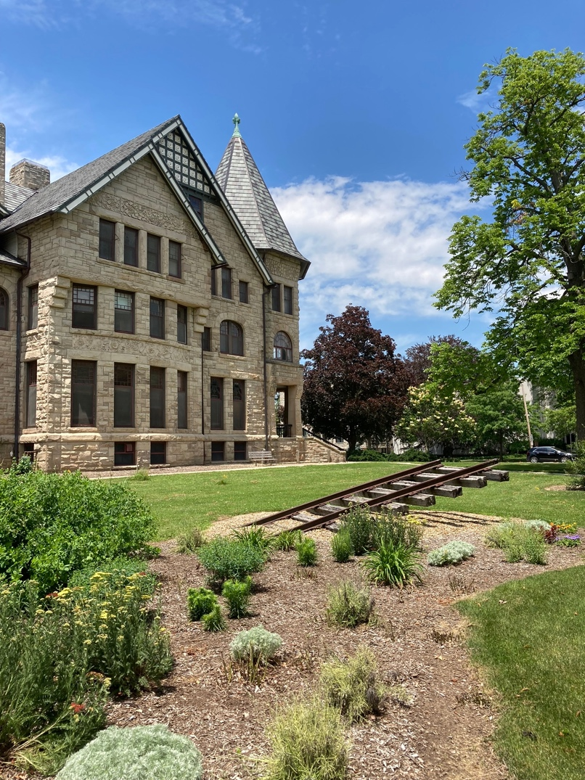
Cameron Armstrong, Underground Railroad Memorial, 1977. Oberlin College, Oberlin, Ohio. Photograph by Geoffrey Jacobson.

Support and Funding
This project was made possible with generous support and funding from the following:
- Michelle Smith Collaboratory of Visual Culture in the Department of Art History and Archaeology at the University of Maryland. The creative energy and use of new digital technologies in the Collaboratory helped this project come to fruition. Henry "Quint" Gregory (Director of the Collaboratory) provided encouragement and guidance on launching the digital repository.
- National Humanities Center/Duke Digital Art History and Visual Culture Research Lab. I was fortunate enough to attend the Summer Institute on Objects, Places and the Digital Humanities led by Caroline Bruzelius and Mark Olson. The series of workshops in July 2017 and July 2018 provided “hands-on” training with tools for geospatial mapping, 3D modeling, photogrammetry, and data collection and visualization.
- National Endowment of the Humanities-Mellon Foundation. In 2018, I received a Digital Publication Fellowship that provided support for the project.
- Getty Research Institute. A residential fellowship at the Getty Research Institute in fall 2018 provided a productive space for thinking about the project. The theme for 2018-2019 focused on "Monumentality"; the visiting scholars constituted a remarkable group of thinkers working on the theme of monumentality and monuments including Jung-Ah Woo, Mara Wade, Inderbir Riair, Samuel Omans, Michalis Olympios, Morgan Ng, Guolong Lai, Elizabeth Kassler-Taub, Cristbol Jacome-Moreno, Raino Isto, Darby English, Nikolas Drosos, Edward Dimendberg, and Rika Burnham.
- Smithsonian Institution Office of Fellowships and Internships. From January - August 2019, I was a Senior Fellow in residence at the Smithsonian American Art Museum. I was fortunate enough to hold the fellowship with a group of scholars working on monuments and/or painting and sculpture of the nineteenth century, including Sarah Beetham, James Brookes, Clarisse Fava-Piz, Kimia Shahi, Phillip Troutman, and Jillian Vaum.
- Brown University. The Office of the Provost provided funding for a two-year visiting professorship (2020-2022) that was extended by the Department of Africana Studies (2022-2025). Professors Brian Meeks and Noliwe Rooks in the Department of Africana Studies provided an intellectually engaging department home while I was at Brown. Joseph Meisel (Joukowsky Family University Librarian) and Allison Levy (Director of Brown Digital Publications) were instrumental in getting me to Brown; and Ashley Champagne (Director) and Khahn Vo (Digital Humanities Specialist) in the Center for Digital Scholarship supported Contemporary Monuments of the Slave Past through a series of focus groups, revisions to the site, and archiving the Omeka digital repository.
Updated January 26, 2026.

